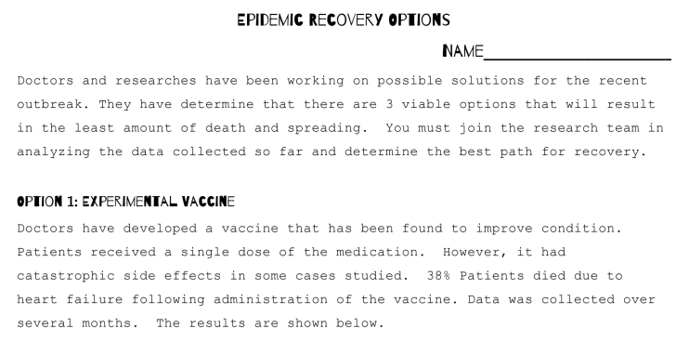
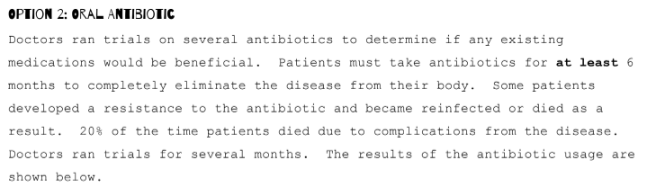

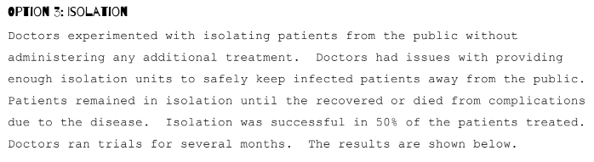

OPTION 1: EXPIRIMENTAL VACCINE

Days passed | Number of people infected (in thousands)
30 | 4
40 | 70
50 | 105
60 | 135
70 | 168
80 | 180
90 | 200
100 | 198
110 | 196
120 | 182
130 | 160
140 | 130
150 | 110
160 | 65
170 | 9

OPTION 2: ORAL ANTIBIOTIC

Days passed | Number of people infected (in thousands)
10 | 50
15 | 40
20 | 39
25 | 36
30 | 32
35 | 24
40 | 21
45 | 14
50 | 12
55 | 8
60 | 5
70 | 2
80 | 0
90 | 1
100 | 2
110 | 8
120 | 15
150 | 35

OPTION 3: ISOLATION

Days passed | Number of people infected (in thousands)
0 | 73
10 | 130
20 | 198
30 | 240
40 | 245
45 | 249
50 | 243
55 | 229
60 | 215
65 | 191
70 | 170
75 | 130
80 | 118
85 | 78
90 | 11

