F
EE
D
C
B
A
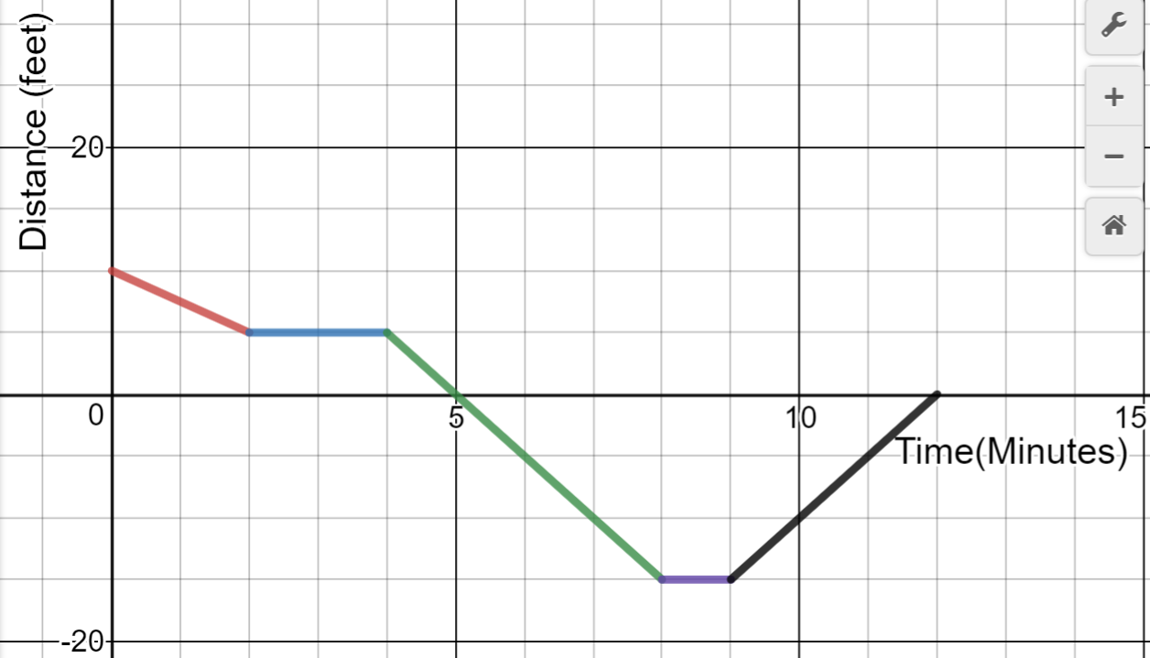
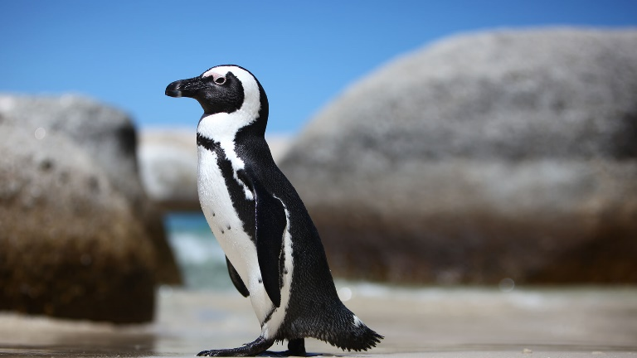
The African penguin is endemic to coastal areas of southern Africa. It is a charismatic species that is known for its loud donkey-like braying noises, distinctive black and white plumage and large breeding colonies. It is a flightless bird that is well adapted to life at sea and land. The body is streamlined with modified wings that resemble flippers, which enable them to be efficient swimmers, and a thick coat with overlapping feathers that assists with waterproofing, wind resistance and insulation. The African penguin has experienced rapid population declines over the past century as a result of overexploitation for food, habitat modification of nesting sites, oil spillages, and competition for food resources with commercial fishing. As a result it is classified as Endangered by the IUCN Red List.
D
C
B
A
E
E
A
C
B
Captain is a South African penguin that is a little bit crazy. One day he is sitting at the top of a cliff looking over the water when he spots a fish. He slides down the rock to the cliff below and he sits patiently at the edge, spotting his prey. He dives in and swims at a steady rate until he spots the fish. He follows it for a while before grabbing it and heading back to the surface to enjoy it.
- How long is Captain underwater? | - What is the rate at which he slides down the rock in segment A? | - What part of the graph is Captain watching the fish from above the surface of the water?
- How deep does Captain swim? | - Does he swim faster in Part C or Part E? How do you know? | - What does the coordinate $(12,0)$ represent?
Write the equation for Captain at Part C:

