Making G.A.I.N.s (Global Awareness by Investigating Numbers)
Algebra 1 – Using Linear Models to Investigate Syrian Refugee Crisis
Guiding Question:
How can using a linear model from data collected in 2015 help Turkey predict the number of refugees from Syria it can expect to support by the end of 2017?

- Examine the data in the given table regarding movement of Syrian refugees into Turkey from January, 2015 through November, 2015. What do you notice?

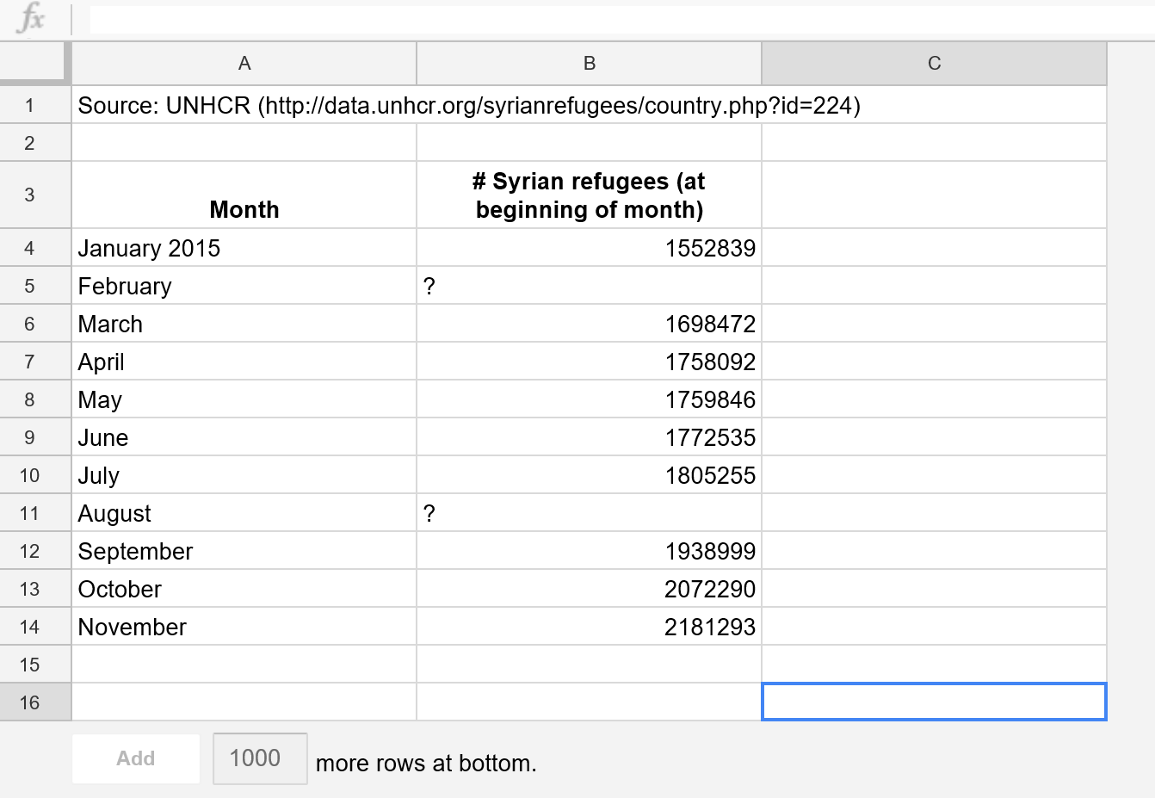

- Determine the rates of change for each of the following:
March – April | April – May | May – June | June – July | September - October | October – November

- In general, what does each rate of change mean in context of the situation?

- Which two months showed the greatest rate of change? Explain how you know.

- Notice that the data isn’t perfectly linear and that no data is available for February and August. Decide on a method you could use in order to determine the possible number of refugees in Turkey during the months of February and August. Explain your method.

- Use your method to determine the number of refugees in February. | - Use your method to determine the number of refugees in August.

- Determine the rate of change for the entire given set of data? (Determine the slope for January, 2015, through November, 2015.)

- Assuming the data from January, 2015 as the starting point, write an equation to relate the total number of Syrian refugees in Turkey for any given month.

- Using your linear model from above, calculate the number of refugees expected in August.

- Is the value different than your first estimation of the same month above? If so, explain why.

- Use your linear model to predict how many refugees Turkey can expect by the END of 2017. Show your work and answer in a complete sentence.

- Use your linear model to determine the number of refugees back in June of 2014. Show your work
answer in a complete sentence.

- Examine the data on the given graph below regarding movement of Syrian refugees into Turkey from January, 2015 through November, 2015.
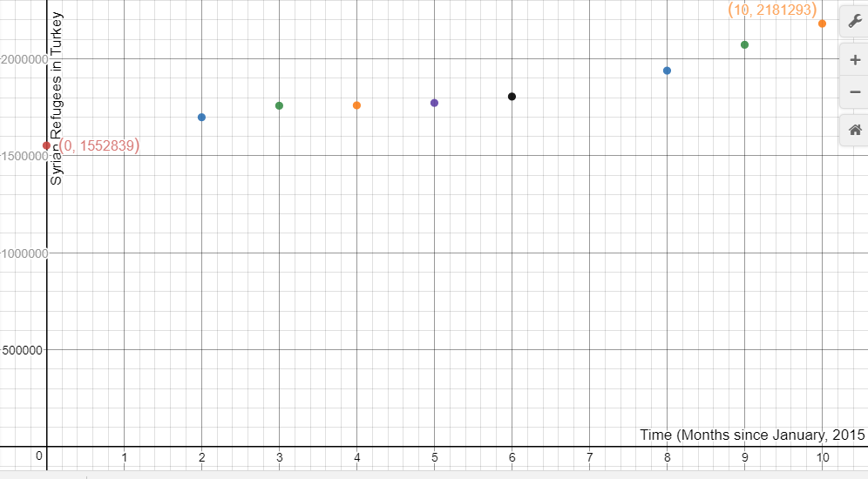
- What do you notice?

- Does this support the statements you made regarding the data table from the table in
Question #1? Explain you reasoning.

- Explain why it is not easy to use the graph to predict future numbers of refugees. What would be a better way to predict future values?

- Explain why it is not easy to use a graph to know exact numbers of refugees. What would be a better way to get precise numbers?

- For what reason might a graphical representation of data be the most useful?

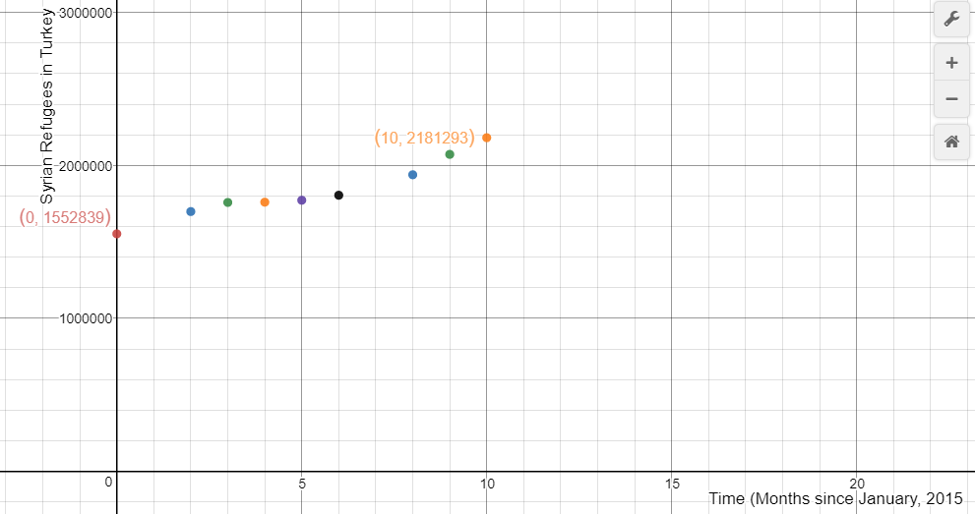

A

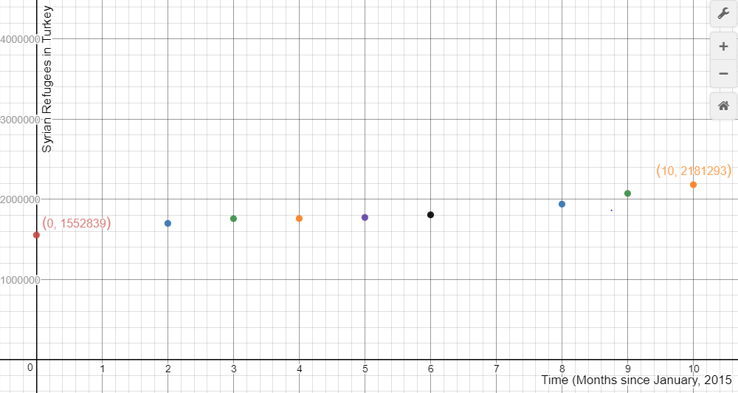

B

- The rate of change for each graph above is exactly the same, but graph A appears to be steeper slope than graph C. What accounts for this difference in appearance?

- The current average rate of spending for refugees in Syria is $500 million. Use the current population prediction obtained in Question #10 of refugees to determine an average cost per refugee.

- Medical care for refugees is a major expense for any hosting country. Syria’s southern neighbor is Jordan, Jordan is also hosting many Syrian refugees. Jordan’s Ministry of Health estimates to have spent more than 50 million US Dollars for the health care of Syrian Refugees for only 4 months. What is the cost per month for medical expenses?

