Name__________________________________ Mrs. Marquardt’s son, Jace, is working with an NGO on the Pacific Coast of Nicaragua to save sea turtles. The most common turtle found on the Pacific Coast is the Olive Ridley. This turtle is named for the greenish color of its skin and shell. It is one of the smallest sea turtles, weighing up to 100 pounds and reaching only about 2 feet in shell length. In food scarce communities, turtle eggs are taken as a source of food or income and endanger the population. At Turtle Tribe, locals are paid to bring the eggs to the reserve, where they are reburied and incubated until they hatch and can released back into the ocean.
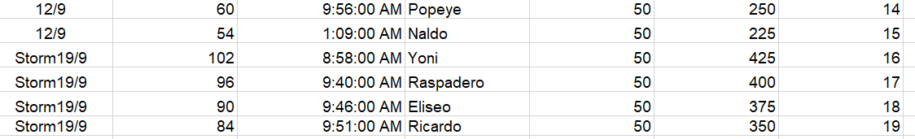
Below is some of the actual excel data collected by Yader, the local that is paid to run the reserve full-time in the community.

They have been collecting eggs for six weeks. By the 3rd week, they had collected 2500 eggs and by the 6th week (this week, they had collected 7900. Graph the given data and then record it in the table below.

Number of Turtle Eggs

Time (Weeks)

Number of Weeks | 0 | 1 | 2 | 3 | 4 | 5 | 6
Number of Eggs
Assuming a constant rate of change, complete the table above, draw the linear function on the graph, and write the equation of the function.

Use the equation to predict the number of eggs they will have collected by the end of the turtle season, which lasts for about 16 weeks.

