Name__________________________________
The turtle collection this year was a huge success! Turtle Tribe has 89 nests and collected 8342 eggs and has positively impacted the population of the Olive Ridley sea turtle in Salinas Grandes, Nicaragua.
- Using the given information above, determine how many eggs a female lays per nest? Show your work.
- The organizaiton Mrs. Marquardt’s son works with, Water and Light, pays $0.12 per egg to locals, which is higher than the price paid in the market. How much money had to be collected in fundraising to cover the cost of purchashing the eggs? Show your work.
- It is estimated that hatch rates of Olive Ridley turtles in the wild average 80-90%, while hatch rates in reserves such as Turtle Tribe are usually 60-80%.
Nest # of Eggs # Hatched % hatch  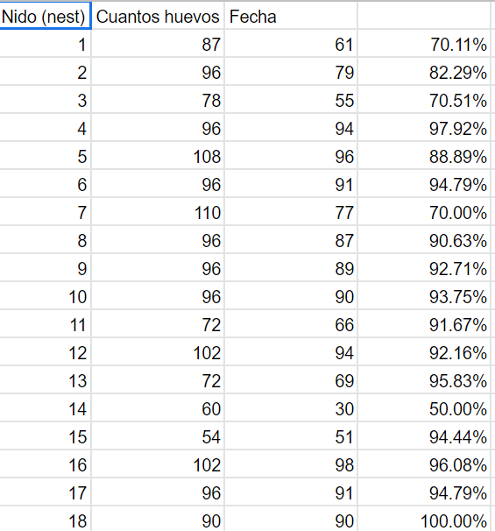 | - Find the average hatch rate for Turtle Tribe over the first 10 weeks.  - How did you find the average? | - How does it compare to rates in the wild? Is it higher or lower than the average at a turtle reserve?  - What factors could account for this?

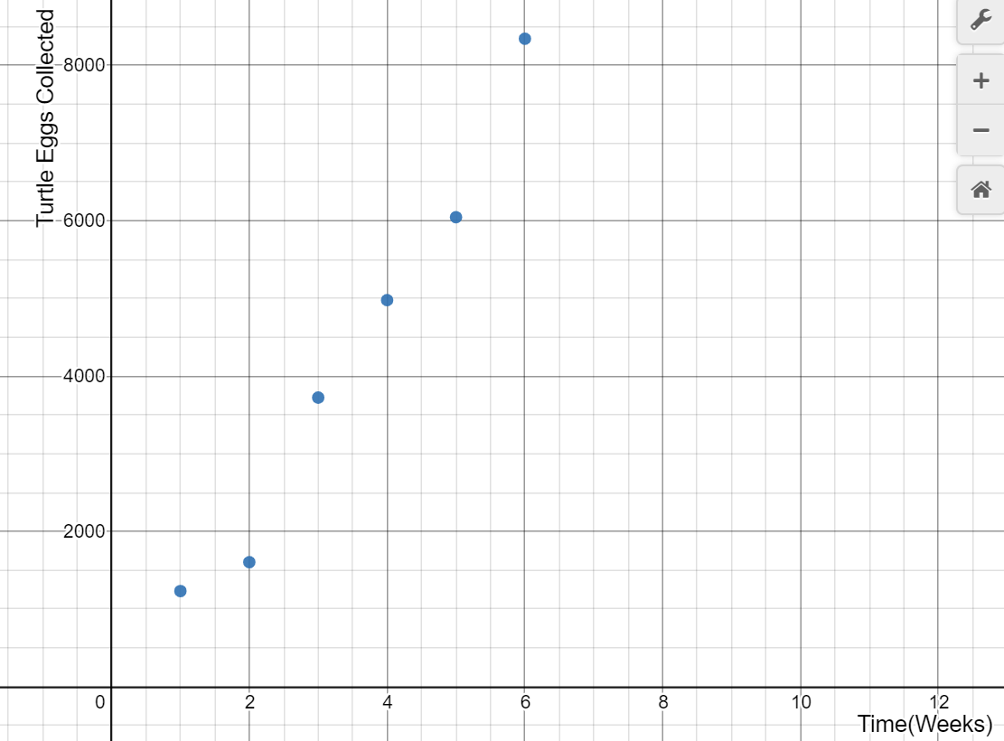
Using the first two weeks of data, create a line on your graph using those two points and write an equation for the line.
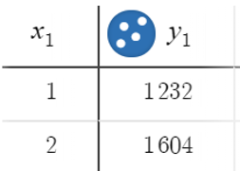
What does the slope represent?
Choose two different sets of points to use to write equations.

Which line predicted more? Which line predicted the least? What difference do those predictions make financially?

Assuming a constant rate of change, complete the table above, draw the linear function on the graph, and write the equation of the function.

Use your equation to predict the number of eggs they will have collected by the end of the turtle season, which lasts for about 16 weeks.

What Is a Marine Biologist?
Marine biologists study life in the oceans, and sometimes the oceans themselves. They may investigate the behavior and physiological processes of marine species, or the diseases and environmental conditions that affect them. They may also assess the impacts of human activities on marine life. Many marine biologists work under job titles such as wildlife biologist, zoologist, fish and wildlife biologist, fisheries biologist, aquatic biologist, conservation biologist, and biological technician.
What Does a Marine Biologist Do?
Marine biologists study marine organisms in their natural habitats. They may investigate a population's behaviors or physiology. Or, they may assess the condition of habitats, and the effects of human activity on those animals and habitats.
Their research typically involves conducting species inventories, testing and monitoring sea creatures exposed to pollutants, collecting and testing ocean samples, preserving specimens and samples of unknown species and diseases, and mapping the distribution, ranges, or movements of marine populations.
In some cases, they may recommend alternative industrial practices to minimize negative effects on marine species and habitats. They may also communicate their findings and recommendations by writing reports and scientific journal articles.
Some marine biologists specialize in marine biotechnology. In other words, they investigate the adaptations and advantages of marine species and how they might be applied to industrial processes. For instance, one biotech company has mimicked the structure of shark skin to create doorknobs that germs and viruses such as MRSA can't attach to. This is a promising and interesting area of the field.
What Is the Average Marine Biologist Salary?
While the U.S. Bureau of Labor Statistics (BLS) doesn't collect data on marine biologists specifically, they are included with zoologists and wildlife biologists. As of 2013, the mean annual wage for these professionals was $62,610, or $30.10 hourly. Those employed by the federal government and in academia earned more than those in state government and other sectors.
What are Marine Biologist education requirements?
A bachelor's or master's degree is typically required for entry-level marine biology research jobs, such as those at private research organizations and biotechnology companies. Doctoral degrees are usually required for faculty positions and other jobs that allow you to follow your own research interests.

